 | Pavel Manger  Contacts:  tel. 0675096699  e-mail: mangerpavel@gmail.com | 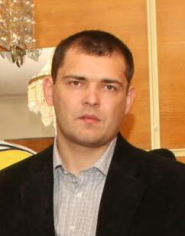

PURPOSE Junior QA
________________________________________________________________________________________________
 | EXPERIENCE  Engineer Cisco, main office bank Oschadbank Kiev— 2014-2016  Fixing and finding failures whole bank’s network  Accomplishments  - fault analysis.  - documentation errors.  - teamwork.  Director, Private firm <Manger P.V>  Kiev — 2007-2014  Sale heating equipments trade in heating appliances .  Accomplishments  - work with customers.  - office equipment support.  - Development and support websites company.  manager, Company<Stamar>  Kiev — 2006-2007  Equipment sales manager .  Accomplishments  - Communicability.  - Organization skills. |  | EDUCATION  Higher education (with honors)  NATIONAL UNIVERSITY OF FOOD TECHNOLOGIES  ( 2002 - 2005). extramural  Faculty of Automation and Computer Systems.  Automation of Control Processes  Secondary special education (with honors)  Kiev Energy College (1998-2002)  Faculty of Automation thermal energy processes  _________________________________________________  SKILLS  advanced user Windows, MS Office, VM  network equipment Cisco,  Making bugs in the bug report  Creature test-case  basic knowledge HTML, SQL  introduction video Jira, Git, Selenium, Jmetre  TRAINING  https://www.codecademy.com HTML  http://www.w3schools.com SQL

